Chemistry
Unit 4
Area of Study 5 Test:
Organic chemistry
This sample test paper has been prepared as part of the Pearson suite of resources for the Year 12, Unit 4, ATAR Chemistry Course prescribed by the Western Australian School Curriculum and
Standards Authority.
Time allowed
Reading time: 5 minutes Working time: 45 minutes
Materials required
An approved non-programmable calculator.
Chemistry Data Booklet. This may be downloaded from the SCSA website.
Structure of this paper
Section | Number of questions available | Number of questions to be answered | Suggested working time (minutes) | Marks available | Percentage of total test
Section 1:  Multiple choice | 6 | 6 | 11 | 12 | 25
Section 2:  Short answer | 3 | 3 | 13 | 14 | 29
Section 3: Extended answer | 2 | 2 | 21 | 22 | 46
Total |  |  | 45 | 48 | 100

Section 1: Multiple choice 25% (12 marks)
This section has 6 questions. Answer all questions by circling the correct option. Marks will not be deducted for incorrect answers. No marks will be given if more than one answer is completed for any question.
Suggested working time: 11 minute
___________________________________________________________________________________

1 Which one of the following alternatives lists compounds in order of increasing solubility in water?
A ethane, ethanol, ethanal, ethanoic acid
B ethane, ethanal, ethanol, ethanoic acid
C ethanoic acid, ethanol, ethanal, ethane
D ethanal, ethanoic acid, ethanol, ethane
2 Which of the following compounds will react with potassium permanganate to form a carboxylic acid?
I CH3CH2CHO
II CH3CH2CH2OH
III CH3CH(OH)CH3
A I only
B II only
C I and II only
D I, II and III
3 Which of the following is the product of the reaction between but-2-ene and hydrogen bromide?
A CH3–CH=CBr–CH3
B CH3–CH=CH–CH2Br
C CH3–CH2–CH2–CH2Br
D CH3–CHBr–CH2–CH3

4 Which functional groups are present in the following compound?
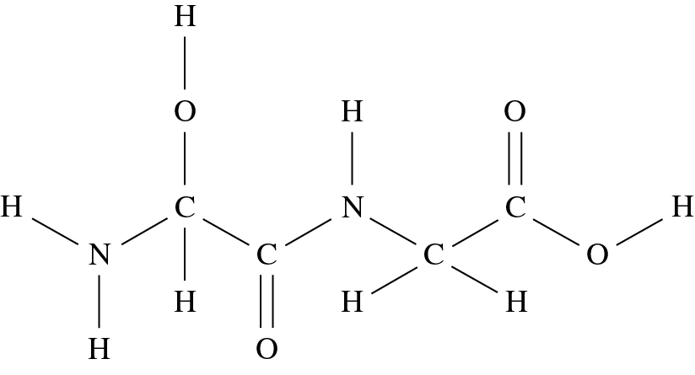
A a carboxylic acid, two amines, an alcohol and a ketone
B a carboxylic acid, an amine, an amide and an alcohol
C two ketones, two amines and two alcohols
D a carboxylic acid, an amide and an alcohol
5 Which acid and alcohol can react together to produce the following ester?
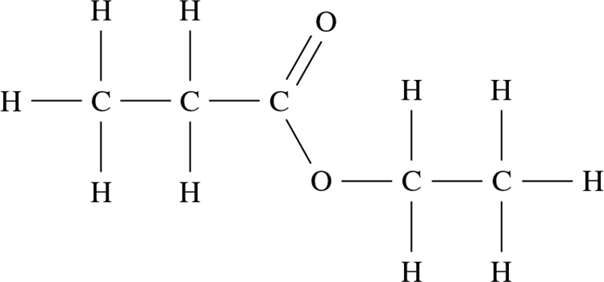
A ethanoic acid and propanol
B propanoic acid and ethanol
C propanoic acid and propanol
D ethanoic acid and ethanol
6 Which of the following compounds have the same empirical formula?
I ethanoic acid
II ethanol
III methyl methanoate
IV ethyl ethanoate
V ethanal
VI propanone
A I, II and V
B I and III
C V and VI
D None of the above
End of section 1

Section 2: Short answer 29% (14 marks)
This section has 3 questions. Answer all questions. Write your answers in the space provided.
When calculating numerical answers, show your working or reasoning clearly. Express numerical answers to the appropriate number of significant figures and include appropriate units where applicable.
Do not use abbreviations, such as ‘nr’ for ‘no reaction’, without first defining them.
Suggested working time: 13 minutes
____________________________________________________________________________________

Question 7 (6 marks)
Give the name and structural formula of the main organic product(s) for the following reactions.
 | Reaction | Structural formula of the main organic product(s) | Name of the main organic product(s)
a | Excess acidified potassium dichromate is added to propan-2-ol.
b | Bromine water is added to cis-but-2-ene.
c | Chloroethene forms an addition polymer. Draw a section of the polymer containing three monomer units.  Note: no name is required.

Question 8 (6 marks)
When ethyl propanoate is heated in the presence of water and an acid catalyst, it produces two organic products, A and B. Product A has a higher molar mass than product B.
a Draw the full structural formula of each in the space below. (2 marks)
Product A | Product B
b Both products are more soluble in water than ethyl propanoate. Account for this difference in solubility. (4 marks)
___________________________________________________________________________
___________________________________________________________________________
___________________________________________________________________________
___________________________________________________________________________
___________________________________________________________________________
___________________________________________________________________________
___________________________________________________________________________
___________________________________________________________________________
___________________________________________________________________________
___________________________________________________________________________
___________________________________________________________________________
___________________________________________________________________________
Question 9 (4 marks)
Bromoethane (CH2BrCH3) can be produced by an addition reaction or a substitution reaction. Write equations to represent both of these reactions.
Addition: ________________________________________________________________________
Substitution: _____________________________________________________________________
End of section 2
Section 3: Extended answer 46% (22 marks)
This section has 2 questions. Answer both questions. Write your answers in the space provided.
When calculating numerical answers, show your working or reasoning clearly. Express numerical answers to the appropriate number of significant figures and include appropriate units where applicable.
Do not use abbreviations, such as ‘nr’ for ‘no reaction’, without first defining them.
Suggested working time: 21 minutes
____________________________________________________________________________________

Question 10 (10 marks)
A compound is known to contain carbon, hydrogen and oxygen only.
a The compound undergoes combustion in excess air to form carbon dioxide and water as the only products. Use the following data to determine the empirical formula of the compound. (6 marks)
mass of compound used in the combustion = 0.827 g
m(CO2) produced = 2.116 g
m(H2O) produced = 0.8655 g
___________________________________________________________________________
___________________________________________________________________________
___________________________________________________________________________
___________________________________________________________________________
___________________________________________________________________________
___________________________________________________________________________
___________________________________________________________________________
___________________________________________________________________________
___________________________________________________________________________
___________________________________________________________________________
___________________________________________________________________________
___________________________________________________________________________
___________________________________________________________________________
___________________________________________________________________________
___________________________________________________________________________
b A sample of the compound, with a mass of 0.4885 g, is vaporised at 150.0°C. The vapour was found to exert a pressure of 133.0 kPa in a vessel of volume of 150.0 mL. Calculate the molar mass of the compound and determine its molecular formula. (3 marks)
___________________________________________________________________________
___________________________________________________________________________
___________________________________________________________________________
___________________________________________________________________________
___________________________________________________________________________
___________________________________________________________________________
c Write a balanced chemical equation for the complete combustion for this compound in excess oxygen. Use the molecular formula of the compound in the equation. (1 mark)
___________________________________________________________________________
___________________________________________________________________________

Question 11 (16 marks)
There are several isomeric alcohols with the molecular formula C5H10O.
a In the space below, draw and name two of these isomers, a primary and a
tertiary alcohol. (4 marks)
 | Primary alcohol | Tertiary alcohol
Structure
Name
b Write two half-equations and hence a fully balanced redox equation to represent the
reaction between the primary alcohol you have drawn and acidified potassium
permanganate solution. (4 marks)
Oxidation: __________________________________________________________________
Reduction: __________________________________________________________________
Full equation: _______________________________________________________________
c In addition to their differing reactivities, the two alcohols you have drawn in part a can also be separated by physical means, by virtue of their boiling points. Identify whether the primary or tertiary alcohol would have the highest boiling point and explain your choice. (4 marks)
___________________________________________________________________________
___________________________________________________________________________
___________________________________________________________________________
___________________________________________________________________________
___________________________________________________________________________
___________________________________________________________________________
___________________________________________________________________________
___________________________________________________________________________
___________________________________________________________________________
End of questions

